Day 5

1.

Program:-

**package** package2;

**import** org.openqa.selenium.By;

**import** org.openqa.selenium.WebDriver;

**import** org.openqa.selenium.WebElement;

**import** org.openqa.selenium.chrome.ChromeDriver;

**import** org.openqa.selenium.chrome.ChromeOptions;

**import** org.openqa.selenium.interactions.Actions;

**import** io.github.bonigarcia.wdm.WebDriverManager;

**public** **class** Exercise1 {

**public** **static** **void** main(String[] args) {

// **TODO** Auto-generated method stub

WebDriverManager.*chromedriver*().setup();

ChromeOptions co=**new** ChromeOptions();

co.addArguments("--remote-allow-origins=*");

WebDriver driver=**new** ChromeDriver(co);

driver.get("https://demoqa.com/droppable/");

Actions a=**new** Actions(driver);

WebElement source=driver.findElement(By.*id*("draggable"));

WebElement dest=driver.findElement(By.*id*("droppable"));

a.dragAndDrop(source,dest).build().perform();

}

}

Output:-

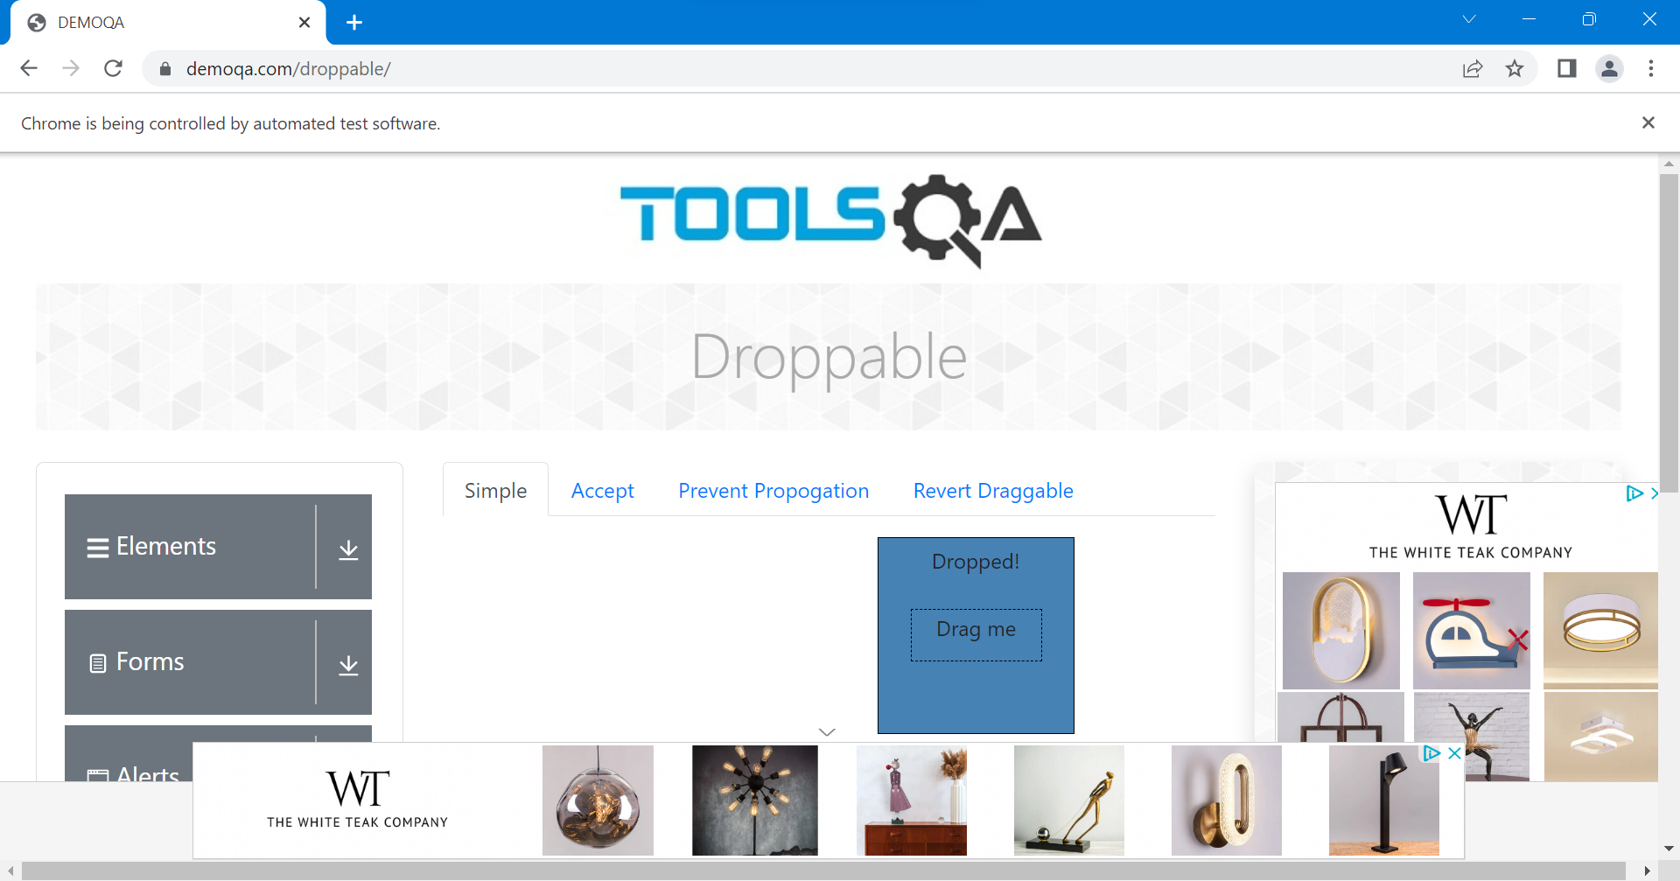

2.

Program:-

**package** package2;

**import** org.openqa.selenium.By;

**import** org.openqa.selenium.WebDriver;

**import** org.openqa.selenium.WebElement;

**import** org.openqa.selenium.chrome.ChromeDriver;

**import** org.openqa.selenium.chrome.ChromeOptions;

**import** org.openqa.selenium.interactions.Actions;

**import** io.github.bonigarcia.wdm.WebDriverManager;

**public** **class** Exercise2 {

**public** **static** **void** main(String[] args) {

// **TODO** Auto-generated method stub

WebDriverManager.*chromedriver*().setup();

ChromeOptions co=**new** ChromeOptions();

co.addArguments("--remote-allow-origins=*");

WebDriver driver=**new** ChromeDriver(co);

driver.get("https://jqueryui.com/droppable/");

driver.switchTo().frame(0);

WebElement drag=driver.findElement(By.*id*("draggable"));

WebElement drop=driver.findElement(By.*id*("droppable"));

Actions a=**new** Actions(driver);

a.dragAndDrop(drag, drop).build().perform();

}

}

Output:-

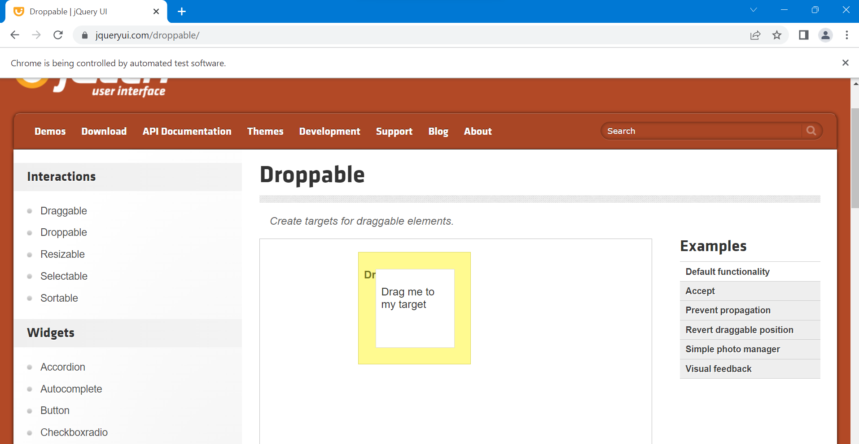

3.

Program:-

**package** package2;

**import** org.openqa.selenium.By;

**import** org.openqa.selenium.WebDriver;

**import** org.openqa.selenium.WebElement;

**import** org.openqa.selenium.chrome.ChromeDriver;

**import** org.openqa.selenium.chrome.ChromeOptions;

**import** io.github.bonigarcia.wdm.WebDriverManager;

**public** **class** Exercise3 {

**public** **static** **void** main(String[] args) {

// **TODO** Auto-generated method stub

WebDriverManager.*chromedriver*().setup();

ChromeOptions co=**new** ChromeOptions();

co.addArguments("--remote-allow-origins=*");

WebDriver driver=**new** ChromeDriver(co);

driver.get("https://demo.guru99.com/test/delete_customer.php");

WebElement cust=driver.findElement(By.*xpath*("/html/body/form/table/tbody/tr[2]/td[2]/input"));

cust.sendKeys("401");

WebElement but1=driver.findElement(By.*name*("submit"));

but1.click();

driver.switchTo().alert().dismiss();

cust.clear();

cust.sendKeys("402");

but1.click();

driver.switchTo().alert().accept();

System.***out***.println(driver.switchTo().alert().getText());

}

}

Output:-

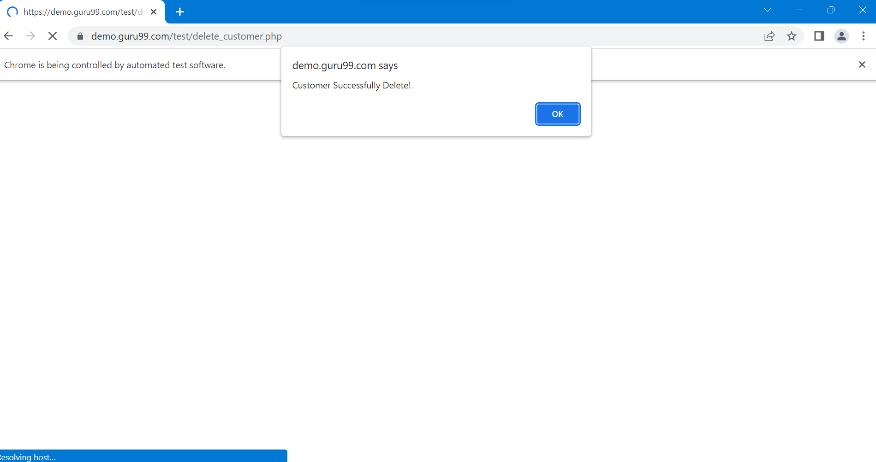

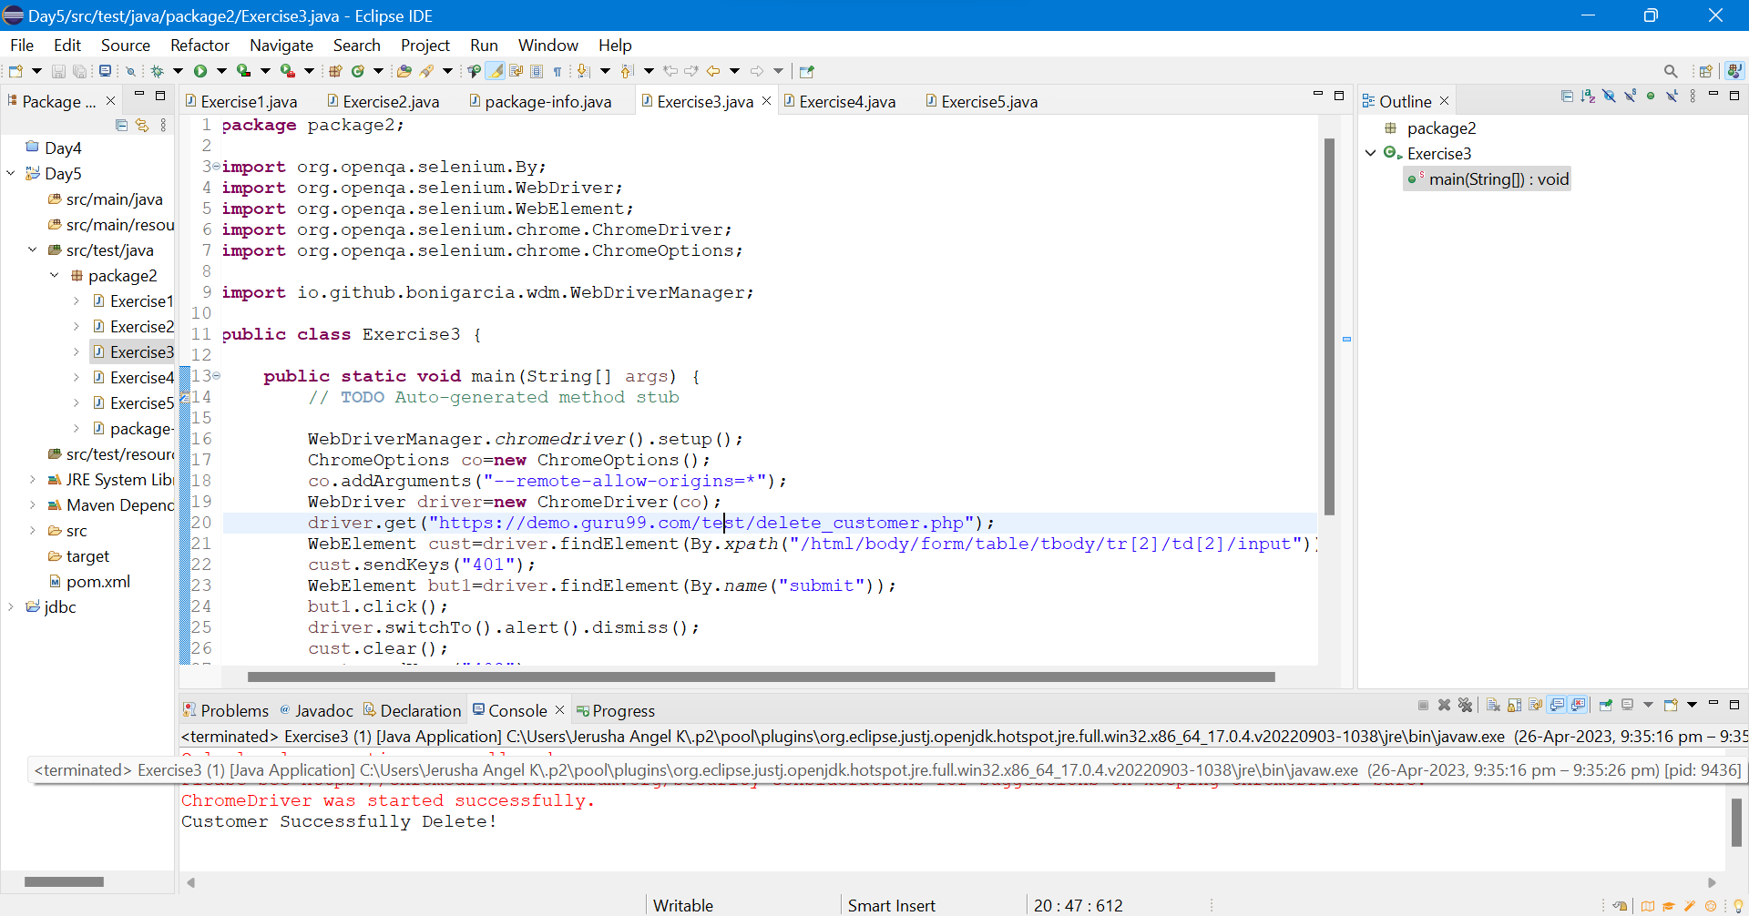

4.

Program:-

**package** package2;

**import** org.openqa.selenium.By;

**import** org.openqa.selenium.JavascriptExecutor;

**import** org.openqa.selenium.Keys;

**import** org.openqa.selenium.WebDriver;

**import** org.openqa.selenium.WebElement;

**import** org.openqa.selenium.chrome.ChromeDriver;

**import** org.openqa.selenium.chrome.ChromeOptions;

**import** io.github.bonigarcia.wdm.WebDriverManager;

**public** **class** Exercise4 {

**public** **static** **void** main(String[] args) {

// **TODO** Auto-generated method stub

WebDriverManager.*chromedriver*().setup();

ChromeOptions co=**new** ChromeOptions();

co.addArguments("--remote-allow-origins=*");

WebDriver driver=**new** ChromeDriver(co);

driver.get("https://www.abhibus.com/bus-ticket-booking");

driver.manage().window().maximize();

WebElement leave=driver.findElement(By.*xpath*("//*[@id=\"source\"]"));

leave.sendKeys("Coimbatore");

**try** {

Thread.*sleep*(3000);

} **catch** (InterruptedException e) {

// **TODO** Auto-generated catch block

e.printStackTrace();

}

leave.sendKeys(Keys.***ENTER***);

WebElement dest=driver.findElement(By.*xpath*("//*[@id=\"destination\"]"));

dest.sendKeys("Tirunelveli");

**try** {

Thread.*sleep*(3000);

} **catch** (InterruptedException e) {

// **TODO** Auto-generated catch block

e.printStackTrace();

}

dest.sendKeys(Keys.***ENTER***);

WebElement date=driver.findElement(By.*xpath*("//*[@id=\"datepicker1\"]"));

date.click();

JavascriptExecutor js=(JavascriptExecutor)driver;

js.executeScript("window.scrollBy(0,100)","");

// WebElement day=driver.findElement(By.xpath("//*[@id=\"ui-datepicker-div\"]/div[1]/table/tbody/tr[5]/td[5]"));

// day.click();

js.executeScript("arguments[0].setAttribute('value','30-04-2023')",date);

WebElement btn=driver.findElement(By.*xpath*("//*[@id=\"seo_search_btn\"]"));

btn.click();

}

}

Output:-

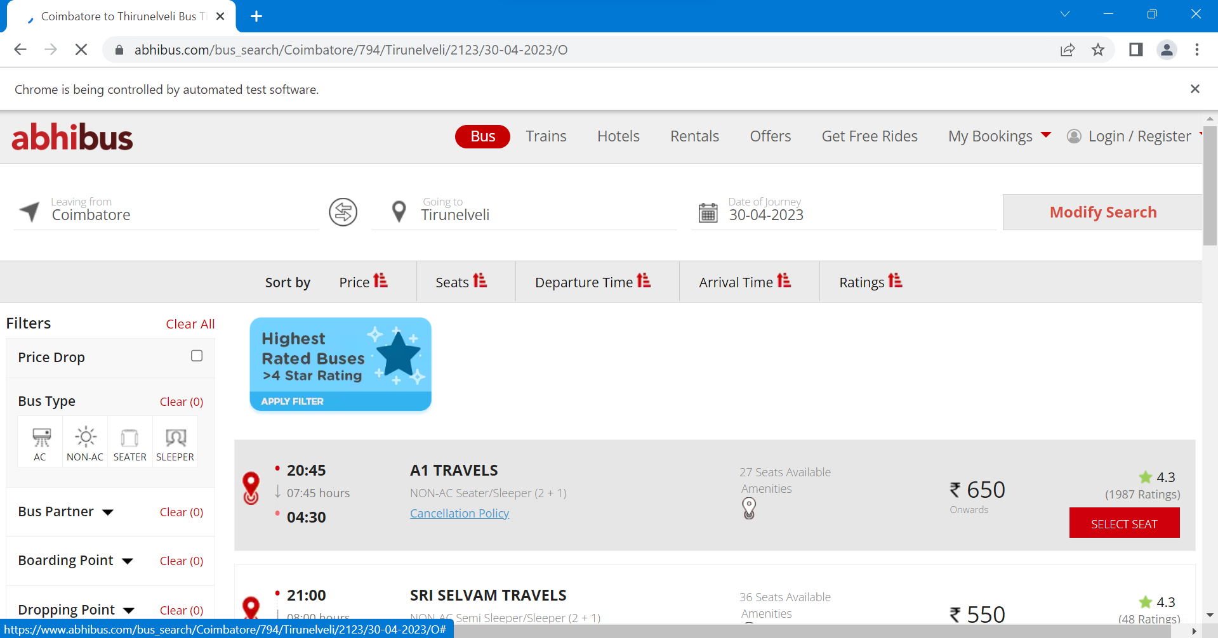

5.

Program:-

**package** package2;

**import** org.openqa.selenium.By;

**import** org.openqa.selenium.Keys;

**import** org.openqa.selenium.WebDriver;

**import** org.openqa.selenium.WebElement;

**import** org.openqa.selenium.WindowType;

**import** org.openqa.selenium.chrome.ChromeDriver;

**import** org.openqa.selenium.chrome.ChromeOptions;

**import** io.github.bonigarcia.wdm.WebDriverManager;

**public** **class** Exercise5 {

**public** **static** **void** main(String[] args) {

WebDriverManager.*chromedriver*().setup();

ChromeOptions co=**new** ChromeOptions();

co.addArguments("--remote-allow-origins=*");

WebDriver driver=**new** ChromeDriver(co);

driver.get("https://www.google.com");

driver.manage().window().maximize();

WebElement new1=driver.findElement(By.*name*("q"));

new1.sendKeys("Apple");

new1.sendKeys(Keys.***ENTER***);

System.***out***.println(driver.getWindowHandle());

System.***out***.println(driver.getTitle());

driver.switchTo().newWindow(WindowType.***TAB***);

driver.get("https://www.google.com");

driver.manage().window().maximize();

WebElement new2=driver.findElement(By.*name*("q"));

new2.sendKeys("Selenium");

new2.sendKeys(Keys.***ENTER***);

System.***out***.println(driver.getWindowHandle());

System.***out***.println(driver.getTitle());

driver.switchTo().newWindow(WindowType.***TAB***);

driver.get("https://www.google.com");

driver.manage().window().maximize();

WebElement new3=driver.findElement(By.*name*("q"));

new3.sendKeys("Cucumber");

new3.sendKeys(Keys.***ENTER***);

System.***out***.println(driver.getWindowHandle());

System.***out***.println(driver.getTitle());

System.***out***.println("Number of Windows Opened "+driver.getWindowHandles().size());

}

}

Output:-

